EXPERIMENT EE 207
THE D.C. GENERATOR

Aim
The aim of this experiment is to study the d.c. generator by carrying out three related tests: an Open-Circuit Test, to obtain the open-circuit characteristics of a d.c. generator by separately exciting its field winding; a Separately Excited Load Test, to obtain the load characteristics of a separately excited d.c. generator; and a Shunt Generator Load Test, to obtain the load characteristics of a shunt excited d.c. generator.

Objective
- To obtain the open-circuit characteristics (E against IF) of a d.c. generator by separately exciting the field winding.
- To find the critical field resistance of the machine from the open-circuit characteristics.
- To obtain the load characteristics (Vt against IL, and E against IL) of a separately excited d.c. generator.
- To obtain the load characteristics (Vt against IL, and E against IL) of a shunt excited d.c. generator, and to compare it with the separately excited generator.

Apparatus
- EMT 180 Machine Assembly (Electrical Machine Tutor-Model) (1)
- Power supply panel with meters (1)
- 500 Ω rheostat (1)
- Tachometer (1)
- 0 – 200 Ω rheostat, on the panel (1)
- Connecting leads

Theory
A d.c. generator is a machine that changes mechanical energy into electrical energy. It has a field winding on the stator, which produces a magnetic flux, and an armature winding on the rotor. When the armature is turned by a prime mover (here, a drive motor), its conductors cut the magnetic flux and an e.m.f. is induced in them, by the principle of electromagnetic induction. The size of the generated e.m.f., E, depends on the flux per pole, Φ, and on the speed of the machine, N, so that E is proportional to Φ × N. If the speed is kept constant, the generated e.m.f. depends only on the flux, and therefore on the field current, IF.
D.C. generators are named according to how their field winding is supplied. In a separately excited generator, the field winding is connected to an independent d.c. source, so the field current can be set to any value, and it does not change when the load changes. In a shunt generator, the field winding is connected across the armature, so the machine supplies its own field current. This is called self-excitation. A shunt generator can start only because of the small residual magnetism that is left in its poles after earlier use.
The open-circuit characteristic (O.C.C.), also called the magnetisation curve, is a graph of the generated voltage, E, against the field current, IF, at constant speed with no load connected. At zero field current, a small voltage is still produced because of the residual magnetism. As IF increases, E rises almost in a straight line at first, and then the curve bends over and becomes flat, because the iron of the machine becomes saturated. In the Open-Circuit Test, the generator is driven at a constant speed of 1200 rev/min and the field current is raised in steps from zero to 1.2 A, while the terminal voltage is recorded at each step. The critical field resistance, Rc, is the highest value of field-circuit resistance at which a shunt generator can still build up its voltage. It is found from the slope of the straight part of the O.C.C., that is, Rc = ΔE / ΔIF.
When a load is connected to the generator, the terminal voltage, Vt, is no longer equal to the generated e.m.f., E, because of the voltage drop in the armature resistance, Ra. For a separately excited generator, the armature current, Ia, is the same as the load current, IL, so that E = Vt + IaRa. For a shunt generator, the armature must supply both the load current and the field current, so that Ia = IL + IF, and E = Vt + (IL + IF)Ra. The load characteristic, also called the external characteristic, is a graph of Vt against IL. The graph of E against IL, called the internal characteristic, is also drawn on the same sheet.
In a separately excited generator, the field current is kept constant, so the terminal voltage falls only slightly as the load increases. This small fall is caused by the voltage drop in the armature resistance and by armature reaction, which slightly weakens the main field. In a shunt generator, the same two effects are present, but there is a third one: as the terminal voltage falls, the field current taken from the armature also falls, which weakens the flux further and makes E fall again. For this reason, the terminal voltage of a shunt generator falls more quickly with load than that of a separately excited generator.

Test 1: Open-Circuit Characteristics (Separately Excited)
Aim: To obtain the open-circuit characteristics of a d.c. generator by separately exciting the field winding, and to find its critical field resistance.

Diagram
Fig. 207-1-1b: D.C. Separately Excited Generator Circuit Diagram
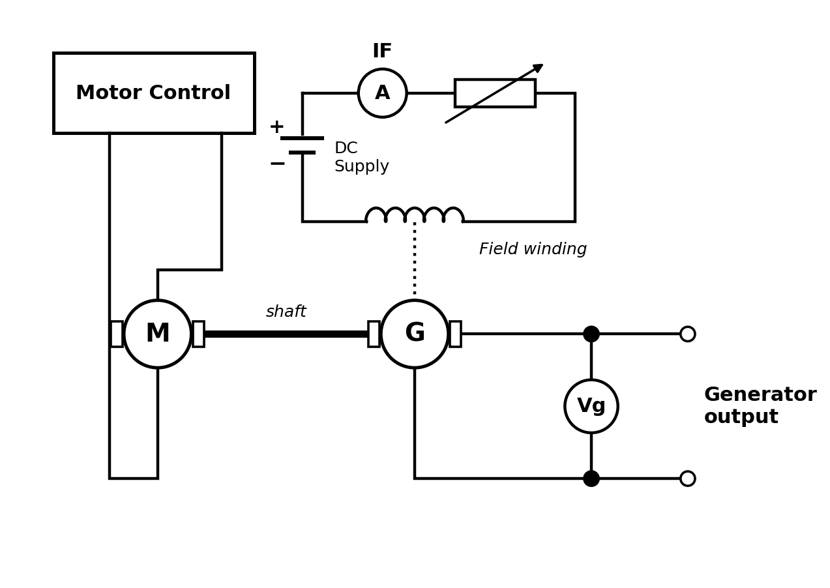

Procedure
- Note the name-plate and the details of the machine under test.
- Connect the circuit as shown in Figure 207-1-1b, and get the supervisor to check all the connections before the power is switched on.
- Make sure that the field power supply switch is OFF.
- Switch ON the drive motor and raise the shaft speed to 1200 rev/min, using the tachometer to check the speed.
- Note the small output voltage that is generated by the residual magnetism in the field circuit.
- Switch ON the field power supply, and increase the field current in steps from zero up to 1.2 A, while keeping the shaft speed constant at 1200 rev/min.
- At each step, record the field current, IF, and the terminal voltage, Vg, on Table 207-1.
- Fill up Table 207-1, and plot a graph of Vg (that is, E) against IF to find the critical field resistance.

Observation
Table 207-1 — Open-Circuit Characteristics Readings (Speed = 1200 rev/min)

S/N | Field current, IF (A) | Generated voltage, E = Vg (V)
1 | 0.0 | 1.5
2 | 0.1 | 4.5
3 | 0.2 | 8.0
4 | 0.3 | 11.0
5 | 0.4 | 14.0
6 | 0.5 | 16.5
7 | 0.6 | 18.5
8 | 0.7 | 20.0
9 | 0.8 | 21.3
10 | 0.9 | 22.3
11 | 1.0 | 23.0
12 | 1.2 | 24.0
Sample calculation: the critical field resistance, Rc = ΔE / ΔIF = (11.0 − 1.5) / 0.3 = 31.7 Ω, taken from the tangent drawn to the straight part of the graph. This gives Rc ≈ 32 Ω.
The generated voltage starts from a small value at zero field current, due to residual magnetism, and then increases almost linearly with the field current. At higher values of IF, the rise becomes smaller and the curve flattens out, because the iron core is approaching magnetic saturation.

Graph
Plot E against IF, with IF on the horizontal axis. Draw a tangent to the straight part of the curve to find Rc. The sketch below shows the expected shape of the curve; replace it with the graph of your own readings.
Graph 1: Open-Circuit Characteristic (E against IF)
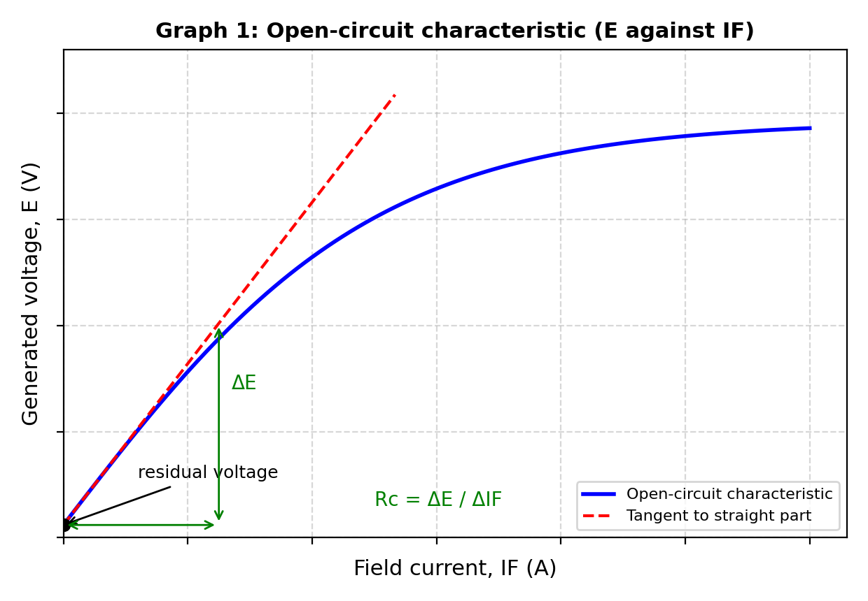

Test 2: Load Characteristics of the Separately Excited Generator
Aim: To obtain the load characteristics of a separately excited d.c. generator.

Diagram
Fig. 207-2-2: D.C. Separately Excited Generator (Load Test)
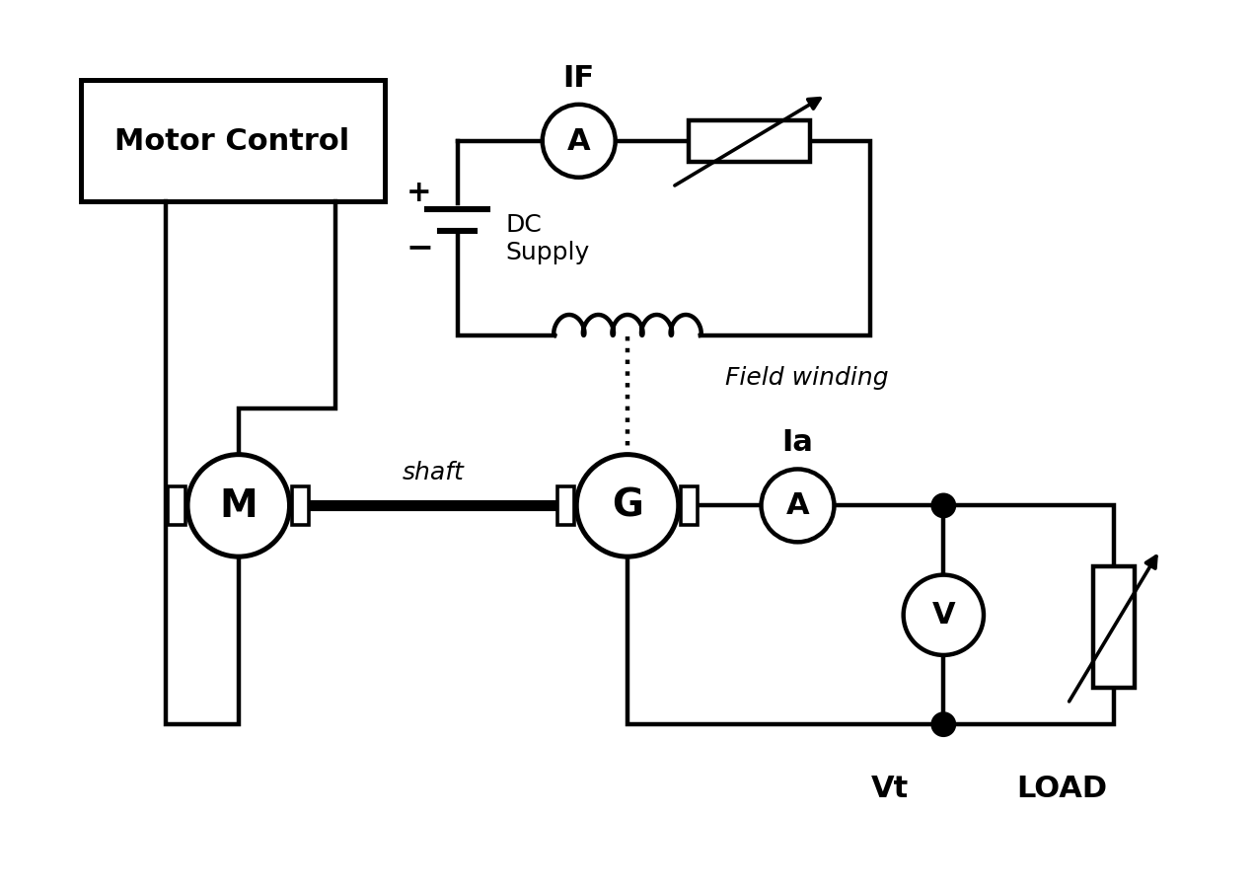

Procedure
- With the same connections as in Figure 207-1-1b, connect the load resistor to the output of the generator, as shown in Figure 207-2-2; get the supervisor to check the circuit.
- Set the load resistor to its highest value (500 Ω).
- Switch ON the drive motor and raise the shaft speed to 1200 rev/min.
- Switch ON the field supply and set the field current to 1.2 A. Keep both the speed and the field current constant throughout the test.
- Record the load current, IL, and the terminal voltage, Vt, on Table 207-2.
- Reduce the load resistor in steps from 500 Ω to about 15 Ω, taking about 15 readings of IL and Vt, until the load current is about 1.0 A.
- Reduce the load and the field current to zero, switch off the supply, and then fill up Table 207-2.

Observation
Table 207-2 — Separately Excited Generator Load Test Readings (IF = 1.2 A, Speed = 1200 rev/min, Ra = 7 Ω)
S/N | Load current, IL (A) | Terminal voltage, Vt (V) | E = Vt + IaRa (V)
1 | 0.05 | 23.6 | 24.0
2 | 0.10 | 23.3 | 24.0
3 | 0.15 | 22.9 | 24.0
4 | 0.20 | 22.5 | 23.9
5 | 0.25 | 22.1 | 23.9
6 | 0.30 | 21.8 | 23.9
7 | 0.35 | 21.4 | 23.9
8 | 0.40 | 21.0 | 23.8
9 | 0.50 | 20.3 | 23.8
10 | 0.60 | 19.5 | 23.7
11 | 0.70 | 18.8 | 23.7
12 | 0.80 | 18.0 | 23.6
13 | 0.90 | 17.3 | 23.6
14 | 0.95 | 16.9 | 23.6
15 | 1.00 | 16.5 | 23.5
Sample calculation (Reading 1): Ia = IL = 0.05 A, and Ra = 7 Ω. Therefore E = Vt + IaRa = 23.6 + (0.05 × 7) = 23.95 ≈ 24.0 V.
The terminal voltage, Vt, falls slightly as the load current increases, because of the voltage drop in the armature resistance and the effect of armature reaction. The generated e.m.f., E, stays almost constant, since the field current and the speed are both kept constant.

Graph
Plot Vt against IL and E against IL on the same sheet, with IL on the horizontal axis. The sketch below shows the expected shape of the curves.

Graph 2: Vt – IL and E – IL (Separately Excited Generator)
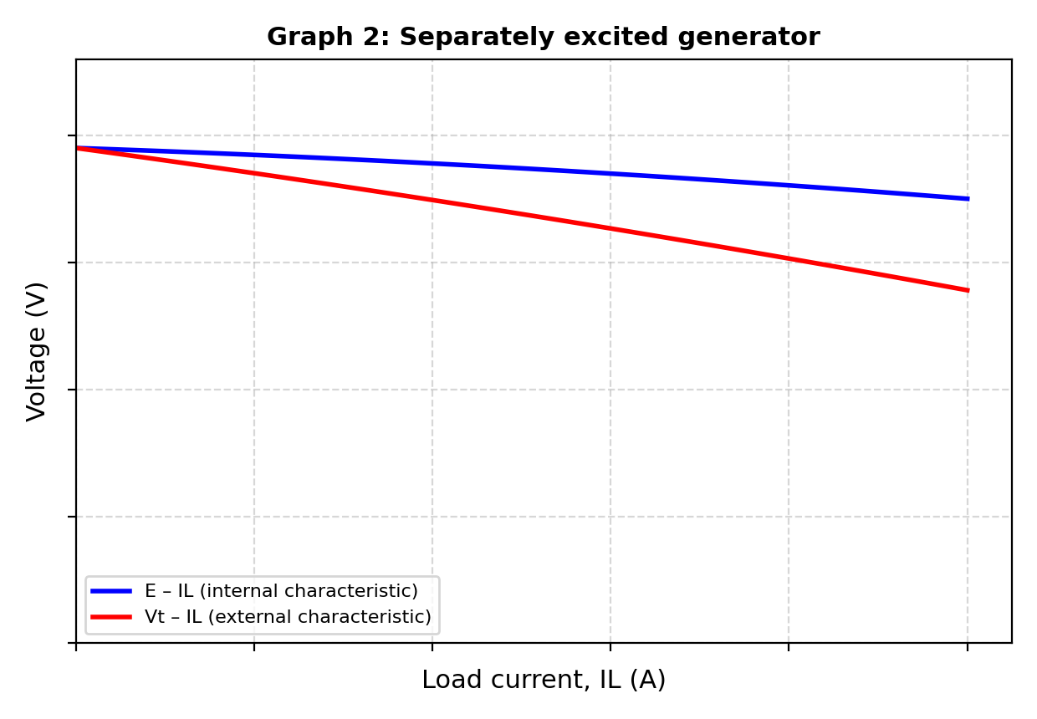

Test 3: Load Characteristics of the Shunt Generator
Aim: To obtain the load characteristics of a d.c. shunt generator.

Diagram

Fig. 207-2-3: D.C. Shunt Generator (Load Test)
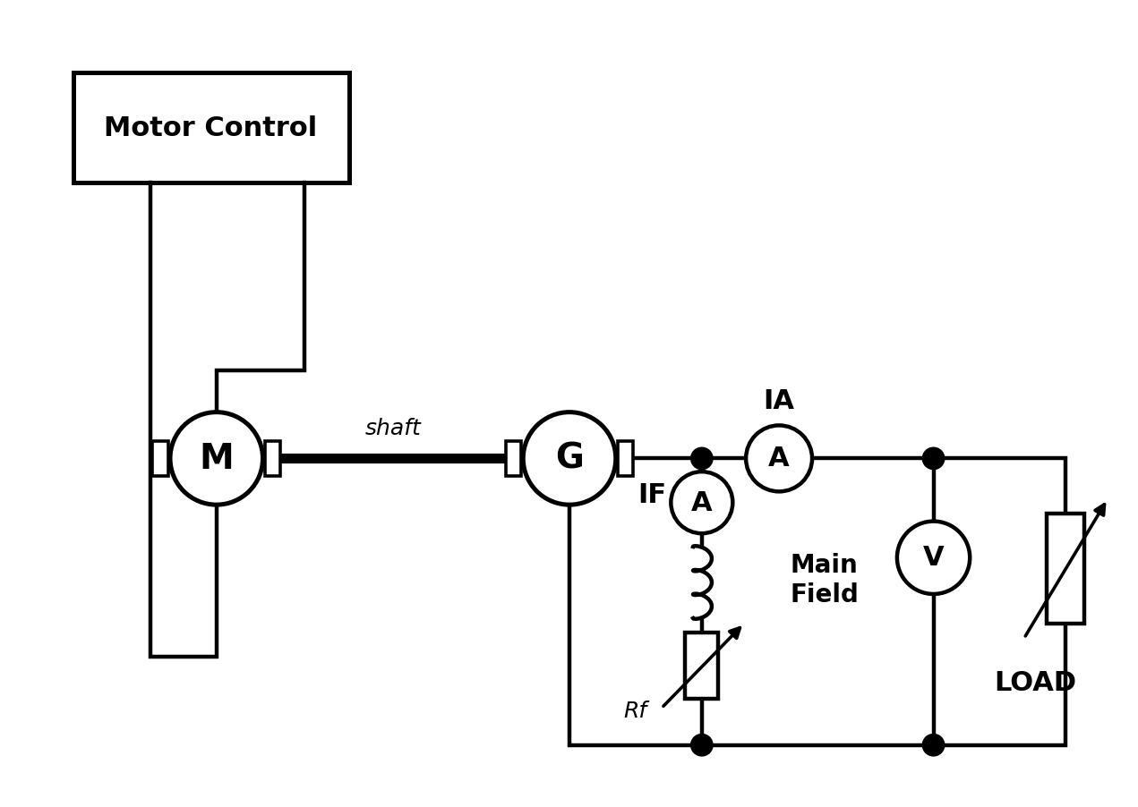

Procedure
- Make the connections as shown in Figure 207-2-3, with the field winding connected across the armature through the field rheostat; get the supervisor to check the circuit.
- Set the load resistor to its highest value (500 Ω).
- Switch ON the drive motor and raise the shaft speed to 1200 rev/min.
- Adjust the field current to 1.1 A, and keep the speed and the field rheostat setting constant throughout the test.
- Record the load current, IL, the field current, IF, and the terminal voltage, Vt, on Table 207-3.
- Reduce the load resistor in steps from 500 Ω, taking about 15 readings of IL, IF and Vt, until the load current is about 0.4 A.
- Reduce the load, switch off the supply, and then fill up Table 207-3.

Observation
Table 207-3 — Shunt Generator Load Test Readings (Speed = 1200 rev/min, Ra = 7 Ω)
S/N | Load current, IL (A) | Terminal voltage, Vt (V) | E = Vt + (IL + IF)Ra (V)
1 | 0.05 | 23.6 | 24.0
2 | 0.10 | 23.3 | 24.0
3 | 0.15 | 22.9 | 24.0
4 | 0.20 | 22.5 | 23.9
5 | 0.25 | 22.1 | 23.9
6 | 0.30 | 21.8 | 23.9
7 | 0.35 | 21.4 | 23.9
8 | 0.40 | 21.0 | 23.8
9 | 0.50 | 20.3 | 23.8
10 | 0.60 | 19.5 | 23.7
11 | 0.70 | 18.8 | 23.7
12 | 0.80 | 18.0 | 23.6
13 | 0.90 | 17.3 | 23.6
14 | 0.95 | 16.9 | 23.6
15 | 1.00 | 16.5 | 23.5
Sample calculation (Reading 1): Ia = IL + IF = 0.03 + 1.08 = 1.11 A, and Ra = 7 Ω. Therefore E = Vt + (IL + IF)Ra = 15.6 + (1.11 × 7) = 23.4 V.
The terminal voltage, Vt, falls with the load current, and it falls faster than in the separately excited generator, because the fall in terminal voltage also reduces the field current and the flux. The generated e.m.f., E, therefore falls as well as the load increases.

Graph
Plot Vt against IL and E against IL on the same sheet, with IL on the horizontal axis. The sketch below shows the expected shape of the curves.

Graph 3: Vt – IL and E – IL (Shunt Generator)
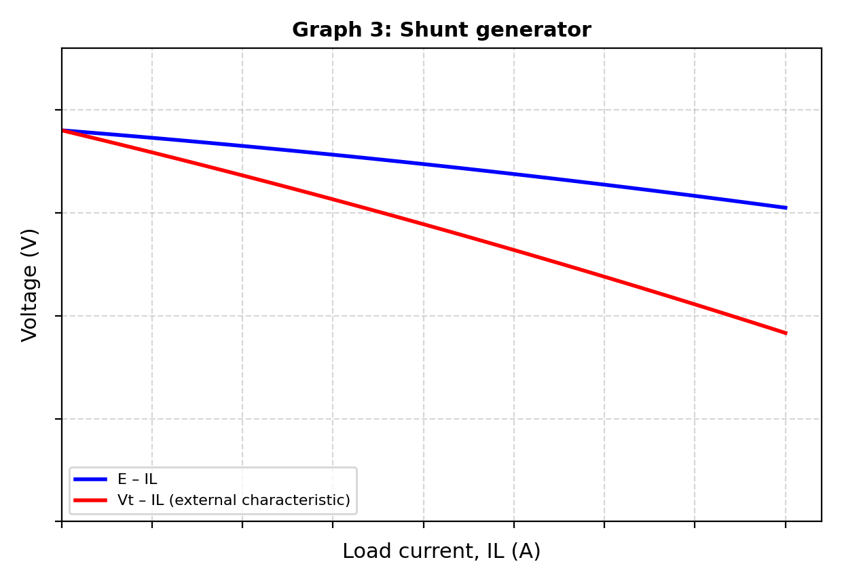

Discussion
(i) Explain the conditions necessary for satisfactory self-excitation of a d.c. shunt generator. Three conditions must be met. First, there must be some residual magnetism in the field poles, since this produces the small starting voltage that begins the build-up. Second, the field winding must be connected the right way round, so that the small current it carries strengthens the residual flux and does not oppose it; if it is connected the wrong way, the voltage dies away instead of building up. Third, the total resistance of the field circuit must be less than the critical field resistance, Rc, found from the open-circuit characteristic. If the field resistance is higher than Rc, the generator will not build up its voltage. In addition, the speed must be high enough, because the critical resistance falls as the speed falls.
(ii) Compare the external characteristics of the separately excited and shunt generators, and explain the difference. In both generators, the terminal voltage falls as the load current increases, but the fall is much greater in the shunt generator. In the separately excited generator, the field current is supplied by an independent source and stays constant, so the voltage falls only because of the armature resistance drop and armature reaction. In the shunt generator, these two effects are also present, but the field current comes from the generator itself. As the terminal voltage falls, the field current falls too, the flux becomes weaker, and the generated e.m.f. falls again. Also, the armature current in a shunt generator is IL + IF, which is slightly larger than the load current. This is why the shunt generator has poorer voltage regulation.

Precaution
- All connections were checked by a supervisor before the power was switched on, in every part of the experiment.
- The name-plate details of the machine were read and noted before starting, and the rated current of the machine was not exceeded.
- The load resistor was set to its highest value (500 Ω) at the start of each load test, and was reduced gradually in steps.
- The shaft speed was kept constant at 1200 rev/min throughout each test, and was checked with the tachometer.
- The field current was increased slowly and in one direction only, to avoid errors caused by hysteresis.
- All connections were made tight, to avoid loose contacts and sparking.
- The meter readings were taken with the eye directly in front of the pointer, to avoid parallax error.
- The load was reduced and the field current brought back to zero before the machine was switched off, and hands and loose clothing were kept away from the rotating shaft.

Conclusion
This experiment showed that the generated voltage ofcv a d.c. generator starts from a small value due to residual magnetism, rises almost linearly with the field current, and then flattens out as the iron core becomes saturated. The critical field resistance was found from the straight part of this open-circuit characteristic. The Load Test on the separately excited generator showed that its terminal voltage falls only slightly as the load current increases, because of the armature resistance drop and armature reaction. The Load Test on the shunt generator showed a larger fall in terminal voltage, because the falling terminal voltage also reduces the field current and the flux. Together, the three tests gave a good overall picture of the characteristics of a d.c. generator, and confirmed that a separately excited generator has better voltage regulation than a shunt generator, while the shunt generator has the advantage of not needing an outside field supply.

